CANDIDATE FOR 2019 PRESIDENT
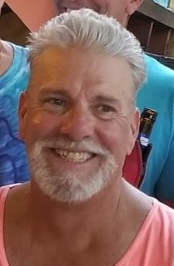
RICK ‘FITZ’ FITZGERALD, aka “Fins Up Fitz”
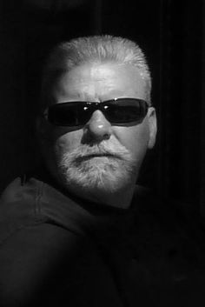
Tracy and I have been in the club for two years. We grew up in Los Angeles, met in high school and have been together ever since. I was in law enforcement for 27 years. For seven years, I was a Los Angeles County Deputy Sheriff. I worked in the men’s central jail for three years in downtown Los Angeles. Then I worked on patrol in south central Los Angeles for four years, eventually becoming a field training officer there.
I relocated to the Sacramento area to get my young, school-aged sons out of LA. As a deputy sheriff in the greater Sacramento area, I worked patrol and as a detective. I spent the last 18 years of my career as a homicide detective.
While in northern California, I was on the board of a yacht club for four years. During that time, I served one year each as Rear Commodore, Vice Commodore and Junior Staff Commodore.
---------------------------------
CANDIDATE FOR 2019 VICE-PRESIDENT
RANDY PAUL STEPHENS, aka “Rum Runner Randy”
I totally live the life of having fun and helping others when given the opportunity. I retired from the Air Force after 21 years and two tours in Vietnam to begin a career as a Professional Golfers of America lifetime member. My most fond memories of being a PGA Club Professional involve helping others enjoy the game of golf. I have given thousands of lessons to beginners and seasoned golfers, including this past summer with Junior Golf Clinics at Hurlburt Field Gator Lakes Golf Course. I have been involved with golf since retiring from the Air Force and have run golf courses from Italy to South Korea, as well as in Texas, Georgia, Alabama, Louisiana, Nebraska, Virginia, Puerto Rico and Florida. During this time, I have met many hundreds of people and am not afraid to make new friends.
With our motto of “Partying with a Purpose,” I would enjoy being your next vice president so I can continue to help others. During the past year, I have been able to bring seven new members into our phlock. I look forward to making a difference to our club.
CANDIDATE FOR 2019 SECRETARY
DEBBIE GARVEY, aka “Little Debbie”
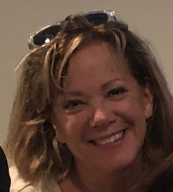
I am honored to be nominated and, if elected, will do my best to fulfill my duties. Just a heads up. These are things I will not do as secretary: I will not get coffee for anyone and I will not pick up dry cleaning. Do Parrot Heads have dry cleaning?
I’ve been to school and some college. I have lots of training in sales, marketing, budgeting and I have a Florida real estate license. I have been a secretary, receptionist, office manager, purchasing agent and retail leasing representative. I can type, record, write and I know what minutes are.
If elected, I look forward to working with those who have been nominated to continue this great club. The Parrot Heads are instrumental in Tom’s and my happiness and phun.
CANDIDATE FOR 2019 TREASURER
WAYNE WILLIAMSON, aka “Voo Doo Wayne”
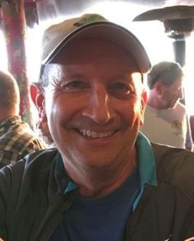
When asked if I would consider running for treasurer, I thought, “No way!” Coming aboard after Buz is a difficult act to follow. Even though I won’t be able to provide the antics that Buz does, I can probably handle the challenges of treasurer. I have an undergraduate degree in accounting, with minors in economics and finance from Miami University, the one in Ohio. I also have an MBA in finance from Xavier University in Cincinnati and had an inactive CPA license for 25 years. My work experience consists of four years of accounting, four years of internal auditing and 30 years working for credit unions in supervisory positions.
If elected, despite being totally unqualified and probably unable to pass an investigation by the US Senate, I promise to devote at least a few minutes per month to my new position to ensure the club’s funds are properly managed and protected to the low standards you’ve become used to.
-------------------------------------
CANDIDATE FOR 2019 BOARD MEMBER-AT-LARGE
MARY BILL, aka “Queen Mary”
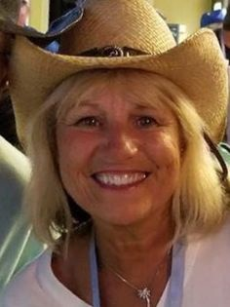
Once upon a time in the faraway land of Wisconsin, I was born. At the age of 18, I moved away to pursue my travel career. I was looking for paradise! I landed in Colorado for 38 years where I met Mr. Bill (ohhhhh nooooooo!!!) Being in the travel industry, I went to many beautiful beaches, but the Emerald Coast was to become our dream come true three years ago when we retired.
After being here for several months, we found the Parrot Heads! I was so honored to become Queen Mary when we joined. I have volunteered and participated in several charity events and I’ve definitely become better at partying, cuz after all…it’s for a PURPOSE!
Our Emerald Coast Parrot Head Club is the best! As a board member-at-large, I will help where I can to keep this club moving forward to help those in need and to make sure we have phun doing it! If you vote for Queen Mary, our club will be sure to get the “Royal” treatment. Thanks for your consideration.
-----------------------------
CANDIDATE FOR 2019 BOARD MEMBER-AT-LARGE
MICHAEL CINELLI, aka “Madcap Mike”
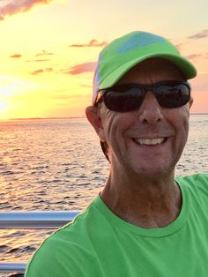
Joining the Emerald Coast Parrot Head Club was one of the best decisions Eileen and I made when we moved to Santa Rosa Beach a little more than a year ago. Meeting some truly great pholks and getting engaged in as many club activities as possible – and there are a lot of them – has enriched our transition from workaday drudgery to bucolic beach life.
Being elected to an at-large position on the ECPHC board would be a privilege and a responsibility. If you all vote me onto the board, know that I will work to make sure the “party with a purpose” focus established years ago will continue for generations of Parrot Heads.
A brief bit of background. I’m a retired journalist/communication executive. I worked on daily newspapers in Texas before joining corporate America where I managed internal and external communication programs for major businesses (banks and airlines), law firms and universities based in Houston. I currently serve on the advisory board of the Mayborn School of Journalism at the University of North Texas (where I met Eileen a few decades ago). That’s it. Now back to the music.
-----------------------------------
CANDIDATE FOR 2019 BOARD MEMBER-AT-LARGE
Lynda Cook, aka “Lynda#1”
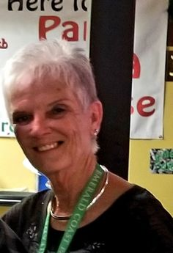
Head Club photographer, but I have volunteered for several other duties since joining the club in 2012.
Linda Belk, Linda McGowen and I sold raffle tickets for a number of years. I have helped decorate our parade float and participated in most of the parades. I have also participated and volunteered for the Chili Cook-off, helped at the Blues, Brews and Barbecue event on the harbor and the car show at Destin Commons. I went to Lynnhaven, FL, with a group of Parrot Heads after Hurricane Michael to help some of our members clean up debris at their homes.
I went to MOTM in Key West last year and had a wonderful time. I hope to go back next year.
I love being active in the Emerald Coast Parrot Head Club and I hope to get your vote for board member-at-large.

